THE LJUBLJANA PRE-CONVENTA FAM TRIP PROGRAMME
29 – 31 JANUARY 2023

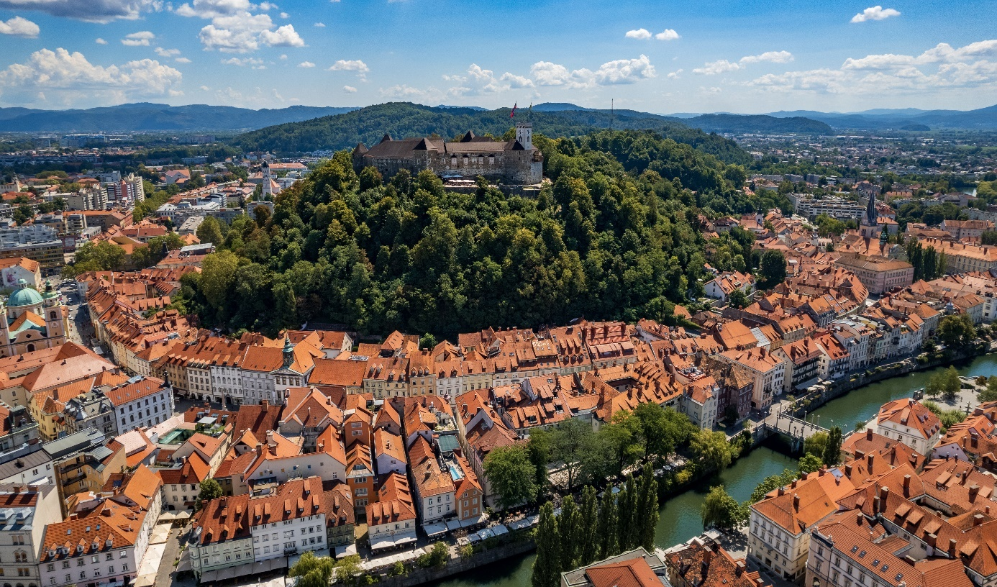
The Ljubljana Convention Bureau, operating within Ljubljana Tourism, invites you to discover a hidden gem among the capitals of Europe just prior to the Conventa Show 2023. The fam trip will provide a good overview of meeting options in Ljubljana in the shortest time and reveal why our city is considered an increasingly popular conference destination in the New Europe region.
A special programme has been designed in cooperation with several destination partners to create a balanced mix of professional and destination / experiential elements, which will take you through different parts of Ljubljana, showcasing several of its attractions. Some special venues will pop up along the way, and the entire experience will be spiced up by a tinge of dolce vita.
Ljubljana, whose name means “The Beloved”, is a compact, walking city of 295,000 residents, which could be defined as a “Yin-Yang” personality or seen as an old lady with a young heartbeat.
With its colourful history that developed over millennia at the crossroads of several cultures, its charm and creative vibe, lively event agenda and relaxed atmosphere, Ljubljana is regarded by many visitors as an unexpected surprise. The efforts invested in its sustainable development have been recognised by the title of European Green Capital 2016, which has left a strong legacy for the years to come. It has also received the coveted title of European Best Destination 2022, which has further strengthened its international visibility and brand.
The Ljubljana Fam Trip, set to start on Sunday 29 January 2023 in the late afternoon, continues through the entire Monday 30 January 2023, as well as in the morning of 31 January 2023, ending after lunch.

Ljubljana invites to be discovered!

SUNDAY, 29 JANUARY 2023
A.M. / P.M.  19:15  19:15 |  | Individual arrivals & transfer to the confirmed hotel.  Slon Hotel – reception  u-Hotel - reception
 |  | Meet up with a representative of the Ljubljana Convention Bureau and welcome to Ljubljana!
19:00 – 21:30 |  | Ljubljana is a compact city and one of its key advantages is the proximity of different event venues and other places of interest. A short stroll along the Ljubljanica riverbanks will lead us to Breg, a restaurant set in a historic building featuring traditional local dishes with a modern twist. Its culinary concept has been developed by Michelin-starred chef Jorg Zupan (Atelje Restaurant).  Return to your respective hotel & sweet dreams!
MONDAY, 30 JANUARY 2023
The itinerary will be entirely walking, also with the aim of providing an initial orientation in
the city centre. Comfortable shoes and relaxed attire are recommended.

08:45  09:00 – 09:45  10:00 – 10:15  10:30 – 11:30  11:30 – 11:45  12:15  13:00 – 14:30  14:30 – 15:15  15:30 – 16:15  16:30 – 17:15  18:45  22:00  8:45  9:00 – 9:30  9:40 – 10:20  10:40 – 11:00  11:30 – 13:00  13:30 – 14:30 | Meeting at the reception of the u-Hotel and Hotel Slon, respectively.  The InterContinental is one of the newest and most starred hotels in town, ready to present its highlights, including one of the best panoramic views wide afar from its top!  Not far away, a short stop at the National Gallery of Slovenia – one of Ljubljana’s most attractive venues for social functions & gala events, comes next.  An enjoyable hands-on experience awaits you at the Best Western Premier Hotel Slon. The content remains a (sweet) surprise…  A few steps further, we’ll go up to the Sky – not literally. Nebo (meaning sky in our language) is a new show restaurant with a great view in the heart of the city.  From there, short walk past the central Post office (time allowing, we’ll have a quick look into its atrium) through the Open Market to the castle funicular. This leads to Ljubljana’s No. 1 landmark, on top of the hill that reigns above the Old Town. Short presentation of the Ljubljana Castle: medieval & modern, historical & multi-functional at the same time; on top, the residence of one of the oldest and most popular Ljubljana pets, the mighty dragon, which is one of the city symbols, also depicted in Ljubljana’s coats of arms.  Lunch at Most – a cosy restaurant with a homely feel just opposite the central market. Connecting them is the Butchers’ Bridge, adorned with statues and, even more, love padlocks. Bon appétit with a meal definitely based on fresh ingredients!  Some local partners will be joining us.  Short walk through a part of the Old Town & visit of the City Museum of Ljubljana – a favoured smaller special event venue. It’s also where the world’s oldest wooden wheel with an axe is on view. Close by, we’ll also peep into the Križanke Summer Theatre, the main venue for the Ljubljana Festival as well as an attractive outdoor event venue.  In green Ljubljana and Slovenia, sustainable development is among the top priorities. A brief visit at Cankarjev dom – CD Congress Centre Ljubljana will provide food for thought. The natural history exhibition “In the Vortex of Change” takes us through the evolution of life on our planet, featuring, among other, the major types of natural environments. Among the question to reflect upon the most difficult one is whether mankind will have the wisdom of foresight to stop the destruction of nature and ensure sustainable development for posterity. And how each one of us can play our part in saving the Earth.  Grand Hotel Union Eurostars - an Art Nouveau jewel and a place of encounter since more than a century. Even royals, heads of state and pop stars love it! A medley of elegance, history & tradition plus a young, creative energy define it at the best. We’ll meet up with our partners of the Eurostars Hotels Ljubljana to learn more about them, while enjoying a refreshing surprise in their traditional café.  Some time at leisure at your hotel.  Get together in the lobby of your respective hotel, walk to the dinner location, the Pen Club restaurant, which is a legend of Ljubljana’s culinary past, now fully refurbished under a new management and a rising star on the local gourmet scene.  Some local partners will be joining us.  Return to your respective hotel & sweet dreams!  TUESDAY, 31 JANUARY 202  Comfortable shoes and relaxed attire are recommended.  Meeting at the reception of the u-Hotel and Hotel Slon, respectively. Short bus transfer.  First stop of the day: Austria Trend Hotel Ljubljana, the closest property to the Stožice Arena & Stadium and a fine convention hotel that is also favoured by sports groups.  Four Points by Sheraton Ljubljana Mons Hotel, a modern property where business is embraced by nature. A new wing has been recently added to the original structure, upgrading its functionality & opening new possibilities. We’ll discover its main features together.  Stopover at Cukrarna Gallery, a former mid-19th century sugar factory that underwent a major renovation. It’s now a new venue dedicated to modern art, which also hosts special events.  We’ll split our group in half for two different memorable hands-on experiences that will enrich you with new skills. Trust us – you will enjoy them!  Walk / alt. green transfer to reach the very central As Restaurant for a farewell lunch. Their Aperitivo section and the classical restaurant are quite popular for business group bookings.  A new boutique hotel will open this spring. Some local partners will be joining us, again.  End of the Ljubljana Pre-Conventa programme; thank you for your understanding in case minor changes would occur. The Conventa Show official schedule follows in the evening, starting with the Welcome reception at the Grand Plaza Hotel.
WE LOOK FORWARD TO WELCOMING YOU SOON IN OUR CITY.
WISHING YOU GOOD BUSINESS @ CONVENTA 2023 AND
A FRUITFUL DISCOVERY OF LJUBLJANA & SLOVENIA!

Contacts of the Ljubljana Convention Bureau team:

Ms Tatjana Radovič Mr Jan Oršič
Manager – Associations Market Head tatjana.radovic@visitljubljana.si jan.orsic@visitljubljana.si
M: + 386 (0)41 977 730 M: +386 (0)31 810 265

www.meetinljubljana.com www.visitljubljana.com

